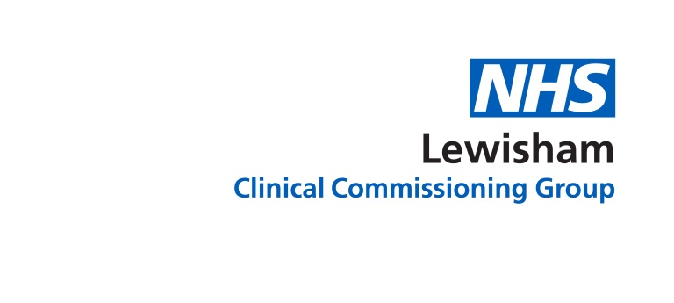

GPEA web content

What is the GP Extended Access Service?
The Extended Access Service has more appointments with GPs available in Lewisham, making it easier for you to get an appointment at a time that suits you, including evenings and weekends.

When are these appointments available?
Appointments are available from 8am–8pm, 7 days a week, including bank holidays. Appointments must be booked in advance.

Who can I access these appointments?
Anyone registered with a GP practice in Lewisham.

How do I book an appointment?
Contact your GP practice in the usual way to request an appointment. If there is no appointment available at your practice, they may offer you an appointment with the GP Extended Access Service, if this is right for you.
If your practice is closed and you need a GP, please contact the out-of-hours service SELDOC on 020 8693 9066 or NHS 111. They will also be able to book an appointment for you with the GP Extended Access Service. Please note that your consent will be required in order for an appointment to be booked for you.
For further information or how to book an appointment online please visit the One Lewisham website or ask at your GP practice.
If urgent care is required please call ‘111’ for further advice. If your need is life threatening, please go to A&E or call 999.
For support with the management of minor ailments, please contact your local pharmacist or visit the NHS Choices website or Health Help Now .

Will I see my own GP and/or nurse?
You will be seen by experienced Lewisham GPs and nurses, but it is unlikely that you will be seen by your own GP or nurse. If you would prefer to see your usual GP or practice nurse, please book an appointment with your usual practice during their normal opening hours.

Will the GP I see have access to my medical record during my appointment?
Your medical record will, with your consent, be available to the GP that sees you, to ensure that they have the information they need to give you the best possible care. Notes of your appointment will be sent back to your own GP practice electronically to ensure that your record is up-to-date. An appointment with this service will be just like an appointment at your own GP practice.
Further information about how we use your medical record is available at the One Health Lewisham website

How do I cancel an appointment?
If you need to cancel the appointment, please call 020 8333 3407 and leave a message stating your name and the time and date of your appointment with the GP Extended Access Service.

Where do I go for my appointment?
The service is located within the Ambulatory Care Centre, University Hospital Lewisham, Lewisham High Street, London, SE13 6LH.

Social media
- We’ve got more GP appts 7 days a week , 8am til 8pm – try the GP extended access service @onehealthlsham @nhslewishamccg
- The #Lewisham GP extended access service has GP appts 7 days a week, 8am-8pm – ask at reception for an appt @onehealthlsham @nhslewishamccg
- We’re offering GP appts 7 days a week 8am until 8pm just ask for the GP extended access service @onehealthlsham @nhslewishamccg

You can get support & info about GPEA from
One Health Lewisham - gpea.ohl@nhs.net​ or call 020 8333 3406

